# ARL ParaPower Thermal Analysis

As part of a collaborative project with the US Army Research Lab (ARL), an API has been developed to utilize their tool, ParaPower (https://github.com/USArmyResearchLab/ParaPower), within the PowerSynth optimization routine. ParaPower provides quick steady-state and transient thermo-mechanical analysis capabilities that can be applied toward the electro-thermo-mechanical co-design of power modules. A brief overview of how the ParaPower API used by PowerSynth is shown below. Additionally, more information regarding this work can be found in ECCE article mentioned in \ref{sec-4}.

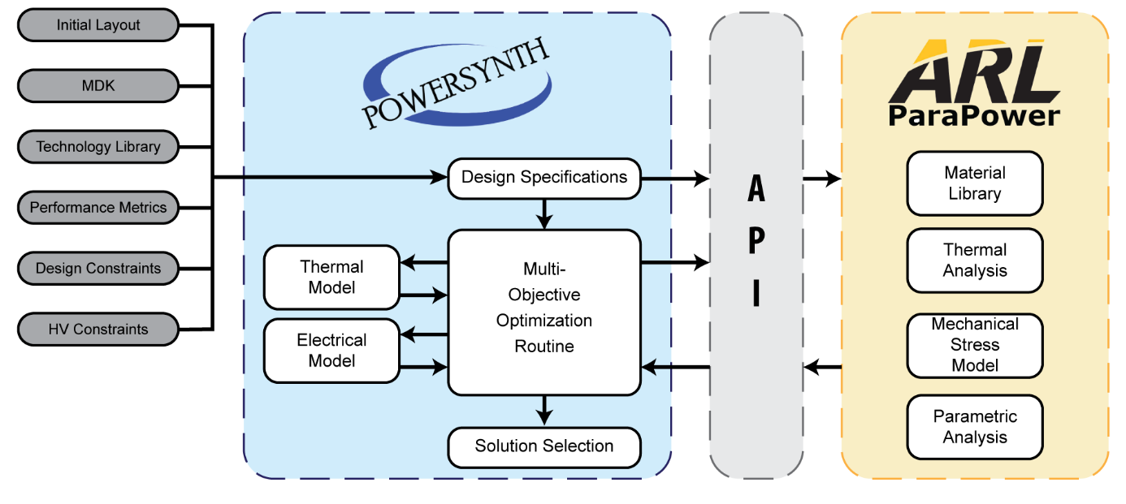

While access to the full analysis capabilities of ParaPower are available through the developer version of this API, for this release of PowerSynth (v1.4) only steady-state thermal analysis is supported. One other caveat is that this is meant to work with the legacy “symbolic layout” power module representation used in PowerSynth and not the newer, layer-stack representation.

To use ParaPower steady-state thermal analysis as a design performance criterion, similar steps are performed as in section \ref{sec-2-5-1}. The main difference being that when choosing the thermal model, the “ParaPower Thermal Model” option should be selected as shown below:

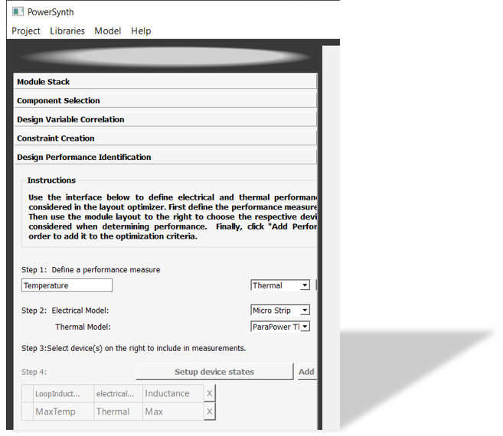

ParaPower offers additional boundary condition settings beyond what this release of PowerSynth considers using the built-in thermal models. The built-in PowerSynth modules only consider temperature and heat transfer from the module backside. Whereas, with ParaPower, these conditions may be specified for all six faces of a rectangular prism enclosing the power module design.

ParaPower analysis boundary conditions and solver settings can be accessed at any point prior to optimization in PowerSynth by choosing “ParaPower Setup” from the “Model” drop-down on the main menu as shown below. Values are automatically populated from the information provided in the “Module Stack” settings pane. Note that these are automatically chosen to mimic the boundary conditions of the other PowerSynth thermal models. If boundary temperature and heat transfer values for any of the other five faces are to be specified, they can be entered manually and then the saved by choosing “Write Settings & Close.”

After ParaPower setup has been completed, along with choosing the ParaPower Thermal design performance criterion, PowerSynth optimization can be executed as normal with the maximum temperature results being added to the solution Pareto frontier.

